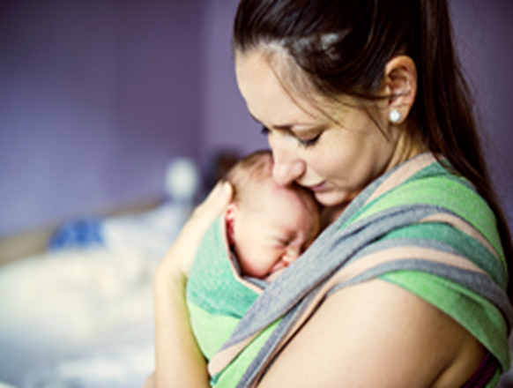

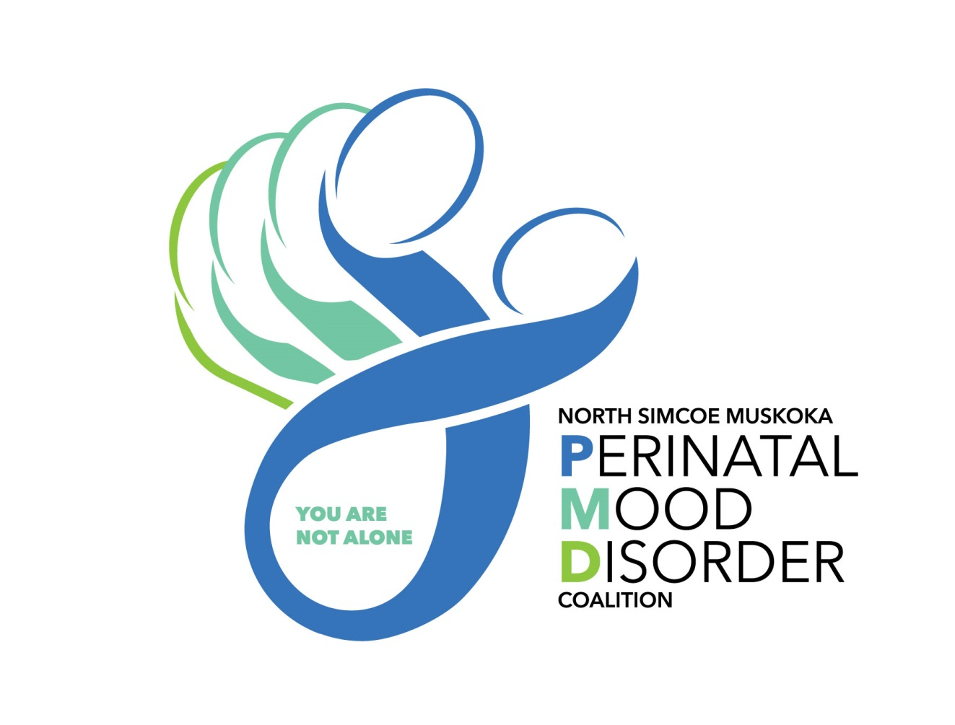

**Need support? You are not alone.**





* + **Meet other new parents experiencing**

**mood changes after birth of baby**

* + **Discuss relationships, difficult emotions**

**and how to take care of yourself**

* + **Build coping skills**

*This group is held at the Georgian Bay Family Health Team –*

*186 Erie St., Collingwood*

*For more information and/or to register please call: 705-444-5885, extension 200.*

**After Baby Group**

For parents with mood changes after baby is born

A series of 6 weekly sessions,

available throughout the year, by registration.